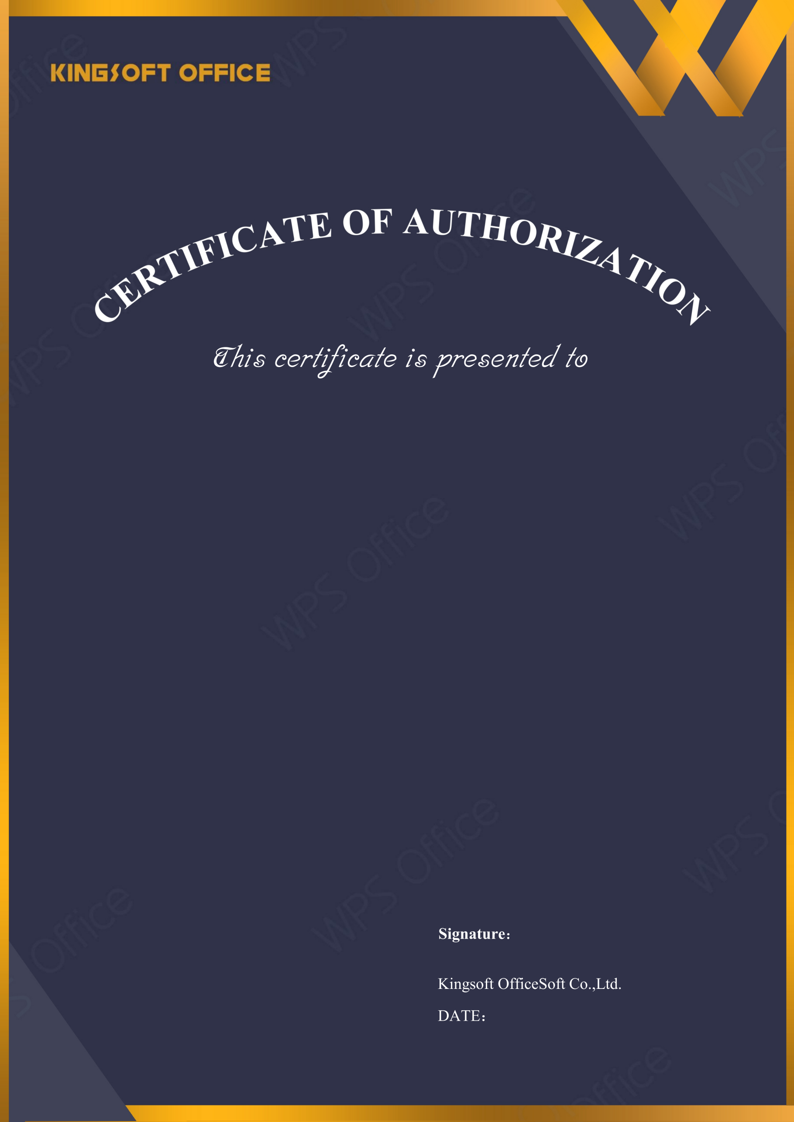
2027-04-06
ICTG. SG

Licensed Software: | WPS Office for Business
License Type: | Quantity License
Licensed Quantity: | 11
License Start Date: | 2026-04-06
License Expire Date: | 2027-04-06
Upgrade Deadline: | 2027-04-06
License Number: | QSWOE-O8QYS-ZW7DR-KHEAG-84CYQ



